**W-Course Project: Transforming Data into a Bar Chart**

**Abstract:**

This paper delineates a program that translates CSV data into a visual representation presented as a bar chart. Using HTML, JavaScript, and Chart.js library, the program facilitates user interaction, data handling, and graphical visualization. The algorithm orchestrates the transformation process, leveraging specific data structures for efficient data management and processing.

**Algorithm for Transforming Data into a Bar Chart:**

1. **File Input:**

* The user uploads a CSV file, comprising tabular data.
* Upon upload, the program reads the file's content as text.

1. **Parsing CSV Data:**

* The text data is parsed into rows by identifying line breaks.
* Extraction of column headers occurs from the initial row, distinguishing columns.

1. **Populating Dropdowns:**

* Dynamically generates options for X-axis and Y-axis dropdown selections.
* Column headers retrieved from the CSV file populate the dropdown lists.

1. **Data Selection and Chart Generation:**

* User selects desired X-axis and Y-axis columns from the dropdown menus.
* Upon button click, data extraction transpires based on user selections.
* Labels for X-axis and data points for the chart are derived from the chosen columns.
* If a chart exists, it is cleared, and a new bar chart is generated using Chart.js.

**List of Data Structures Used:**

1. **csvData (String):**
   1. Stores the CSV data retrieved from the uploaded file.
2. **myChart (Chart object):**
   1. Represents the Chart.js object responsible for rendering and managing the bar chart.
3. **rows (Array of Strings):**
   1. Contains each row of data from the CSV file as an individual string.
4. **headers (Array of Strings):**
   1. Houses the column headers extracted from the CSV file.
5. **labels (Array of Strings):**
   1. Holds the labels for the X-axis of the bar chart.
6. **data (Array of Numbers):**
   1. Stores the numerical data points for the Y-axis of the bar chart.

**Input Example 1:**

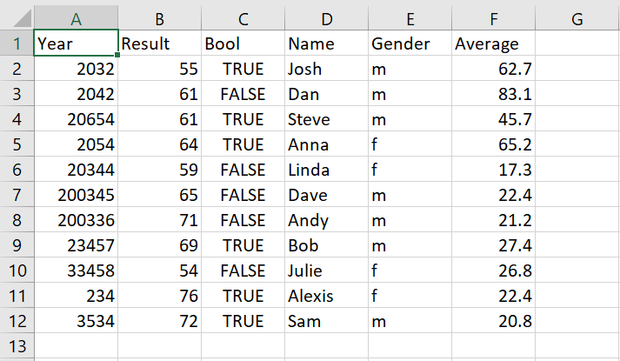

**Output Example:**

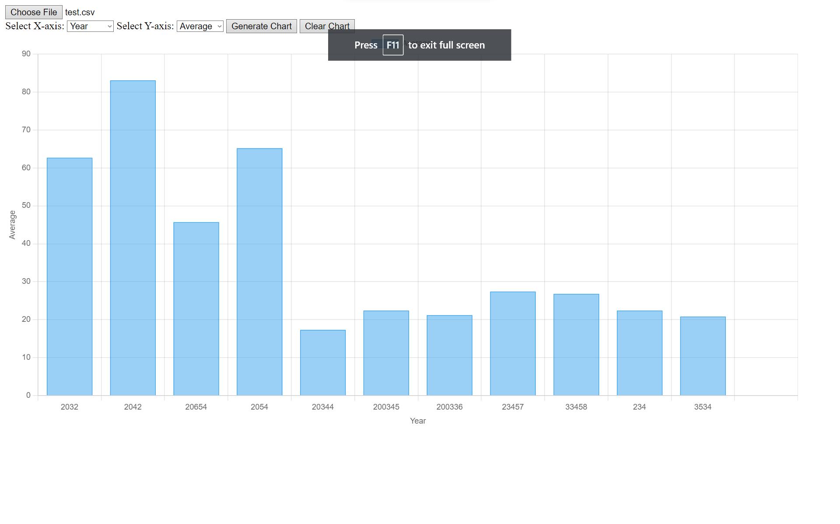

**Link to Web Application:**

<https://barchartproject.w3spaces.com/HomePageBarGraph.html>

**Link to Project File with Sample CSV:**

<https://drive.google.com/drive/folders/1s58Euag4nN__xQazqPzupa6ygG4DDote?usp=sharing>

**Work Cited**

Tripathi, Saurav. "Data Visualisation In Java." Web, Published on Sep 13, 2021,

<https://sauravmanitripathi.medium.com/covid-19-data-visualizer-in-java-466552805489>.

createwithdata.com. "Visualising CSV data with Chart.js." Web, Published on Jan 19, 2019, Available at:

<https://www.createwithdata.com/chartjs-and-csv/>.

Yi, Mike. "A Complete Guide to Stacked Bar Charts." Web, Available at:

<https://chartio.com/learn/charts/stacked-bar-chart-complete-guide/>.